EXP 3:
The stakeholders have conflicting views on the user interface design
for an E-Commerce mobile app. Create a prototype using Figma tool
to discuss with the stakeholders to get their feedback and approval.
step 1:
- Click the Frame tool at the top (looks like a # or a frame icon).
On the right panel, you'll see frame sizes.
- Click on the frame.
- On the right side, find Fill.
- Click the colour box.
- Choose any colour.
- Close the colour picker.
- Press T.
- Click inside the frame.
- Type:
Bus Ticket Booking
Draw a Button
- Press R.
- Draw a rectangle.
- On the right:
  - Change Fill colour.
  - Increase Corner Radius (for rounded corners).

Step 1:
Enter your name and your mobile number and click on register now to register your details

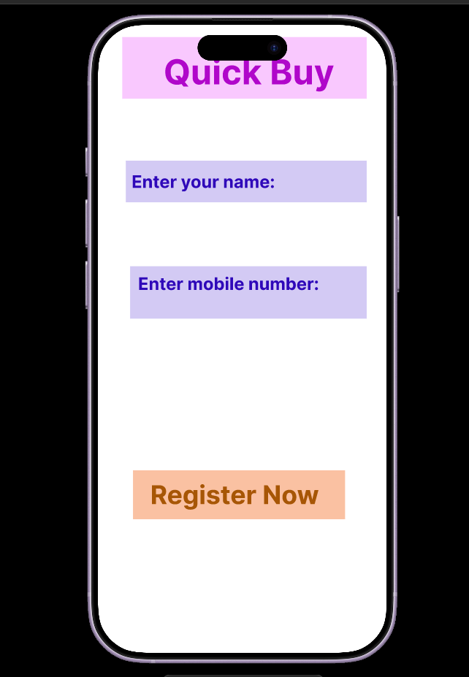

Step 2 :
Enter the OTP which has been sent to your register mobile number and click on verify to verify your account.

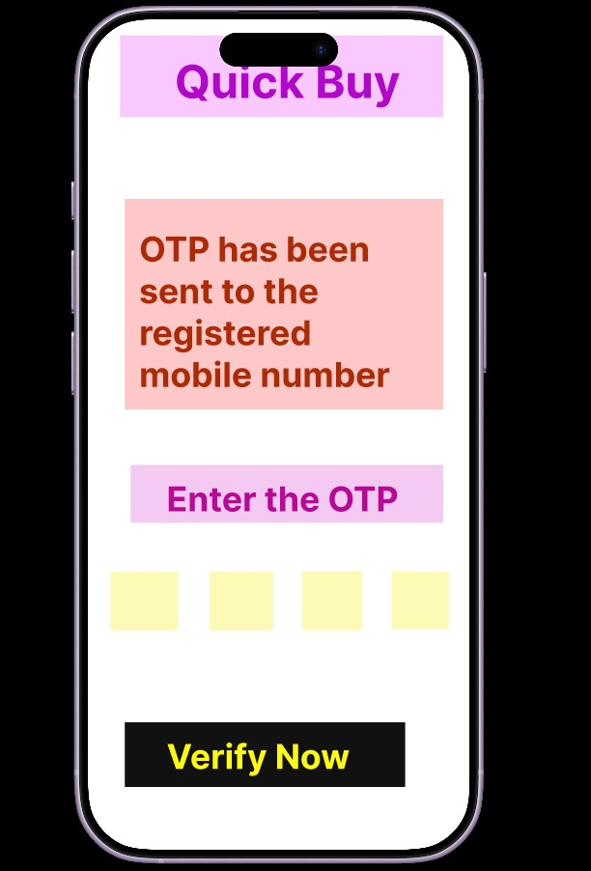

Step 3 :
This is the home page where u can search for the products which you wish to buy.

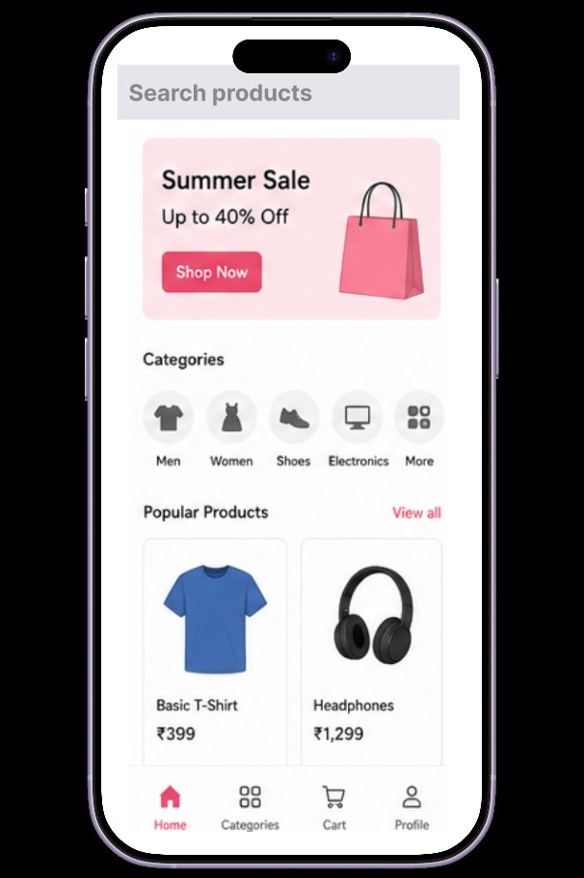

Step 4 :
After choosing product click on Add to cart or Buy now

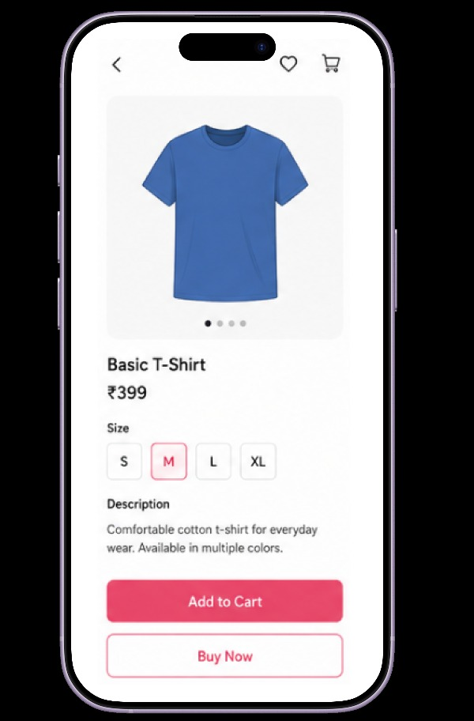

Step 5 :
Add your delivery Address and choose the payment method and click on Place order,then your order would be confirmed successfully

